Name: _______________________________ Lab Period/Time: _______________

/4pts
Preview for Lecture Assignment
#5: Respiration
- Watch Video or use your textbook to complete the following work.
- Write a Summary. Other Options: If you are a visual learner, you are welcome to draw out your summary. If you are an auditory learner, you are welcome to record a verbal summary and submit it electronically.
- Submit this in the first 5 minutes of class in the lecture we cover this content. Or submit electronically on Canvas before the start of class.
Chapter 22 (all of it)  Or  These Videos:  Vid#1:  (Time: 9:21) https://www.youtube.com/watch?v=bHZsvBdUC2I  Vid#2:  (Time: 8:45,  start at 3:49)  https://www.youtube.com/watch?v=MrDbiKQOtlU  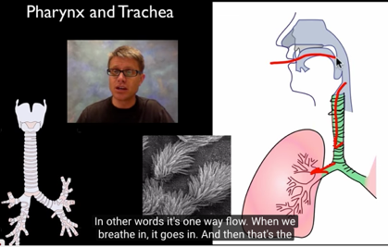 | Questions:  - Vid1, (5:45Mins in): Label the path of air from your mouth to your alveoli and give a quick summery of each organs role. Vid2: What is speciation?  - Name:  - Function:  - Name:  - Function:  - Name:  - Function:  - Name:  - Function:  - Name:  - Function:  - Name:  - Function:  - Create a pneumonic device to remember the path:  - What is the purpose of cilia?  - Explain the gas exchange occurring at the Alveoli  How is oxygen/O₂ gas moved? How is CO₂ gas moved?
Summary:

