BBQ#10: ATP Questions
How do biological organisms use energy?

The Importance of ATP
Living organisms use a two-step process to provide the energy needed for most biological processes.

I. First, cellular respiration makes ATP from ADP plus a phosphate (P). The energy for this chemical reaction is provided by the cellular respiration of sugars or other organic molecules.

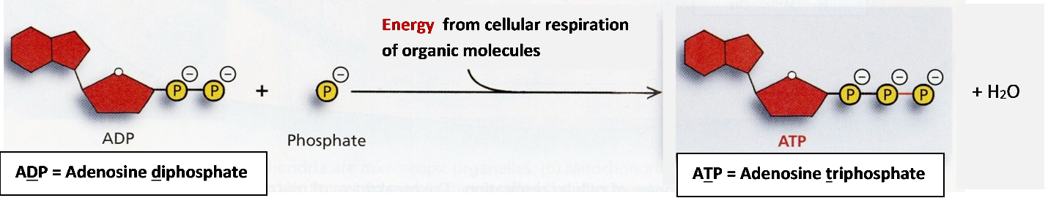
II. Then, the hydrolysis of ATP provides the energy for most biological processes. When ATP and water react to form ADP plus a phosphate, this reaction releases energy which is used for many different cellular processes.

To Do:
1. Give one reason why the reaction, ADP + P ATP + H₂O, requires energy input. (Hint: Notice the charges of the molecules in the top figure.)

2a. Inside each cell, there is a constant cycle of synthesis and breakdown of ATP. Add to this diagram to show:
- How cellular respiration contributes to the production of ATP
- How the hydrolysis of ATP to form ADP + P is useful.

2b. Explain why a cell needs to constantly break down and synthesize ATP.

3. Explain why your body gets warmer when you are physically active.

By Dr. Ingrid Waldron, University of Pennsylvania, 2016.

