Mitosis and Meiosis Practice Test
Mitosis Activity:
- Identify the Stages of Mitosis and draw in what each cell looks like.
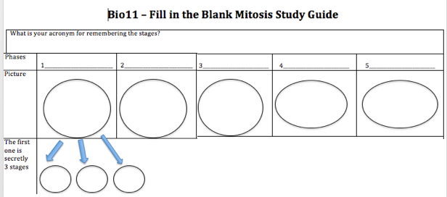

- When do you do mitosis? ____________ & _____________
- How is mitosis different than meiosis?

Meiosis Activity:
- What are the three major differences between Meiosis #1 and Mitosis?
______________________________ which occurs in ______________________ phase.
______________________________ which occurs in ______________________ phase.
______________________________ which occurs in ______________________ phase.

- Identify the Stages of Mitosis and draw in what each cell looks like.
Meiosis 1 | - Interphase 1 | 2__________________ | 3______________ | 4_________________ | 5_________________
Picture
Meiosis 2 | 1______________ | 2_____________ | 3____________ | 4__________________ | 5___________________
Why doest the cell go therough interphase again in meiosis 2?
_________________
__________________
__________________

- Genetic Variation is caused by these 3 things?
________________, __________________, _______________
- Why is genetic variation a good thing? (Connect it to evolution.)

