Name: __________________________________ Lab:____________________
- Tell the story of THE EVOLUTION OF REPRODUCTIVE TISSUE
WORD BANK:  - Bryophyte  - Charophyte  - Gymnosperm  - Angiosperm  - Pterophyte | - Spores  - Seed  - Competition  - Pollinators  - Wind  - Sperm  - Naked Seed  - Costs many calories  - Pine Cone  - Provide nourishment for the offspring  - Water  - Seed Coat  - Spread the offspring away from the mother  - Conjugation
(#)__________ lives its whole life in water and use __________ to reproduce. The Limitation of this method is that it: __________.
(#)__________ and (#)__________ lives near water and uses __________ to reproduce. The limitation of this method is that it requires them to live close to __________ so that its __________ can swim to the egg.
(#)__________ uses __________ to spread its pollen to the female plant. Once fertilized the embryo of Pine Trees is contained inside a __________ that requires a __________ to protect it. One advantage of this protection method is that it helps to __________ and limits __________ between parent and offspring.
(#)__________ have beautiful flowers to attract __________ . The main limitation to this method is that this __________ . The advantage of this method is that it uses fruit to __________ and __________.

- Explain what is happening in each of these pictures:
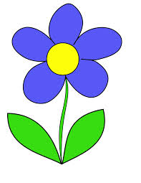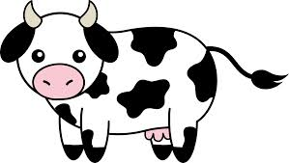

O₂
Energy
CO₂ + H₂O
- Photosynthesis Equation:
Write it out as a sentence:

- What do plants “breathe” in and why?

- What organelle does photosynthesis take place in?

- Where does it have extra surface area and why?

- Why are plants green?

- Complete the diagram:
