Pre-lab 12 – Histology
Compact Bone – Osseous Connective Tissue
http://homepage.smc.edu/wissmann_paul/bones/1compactbonehistology.html
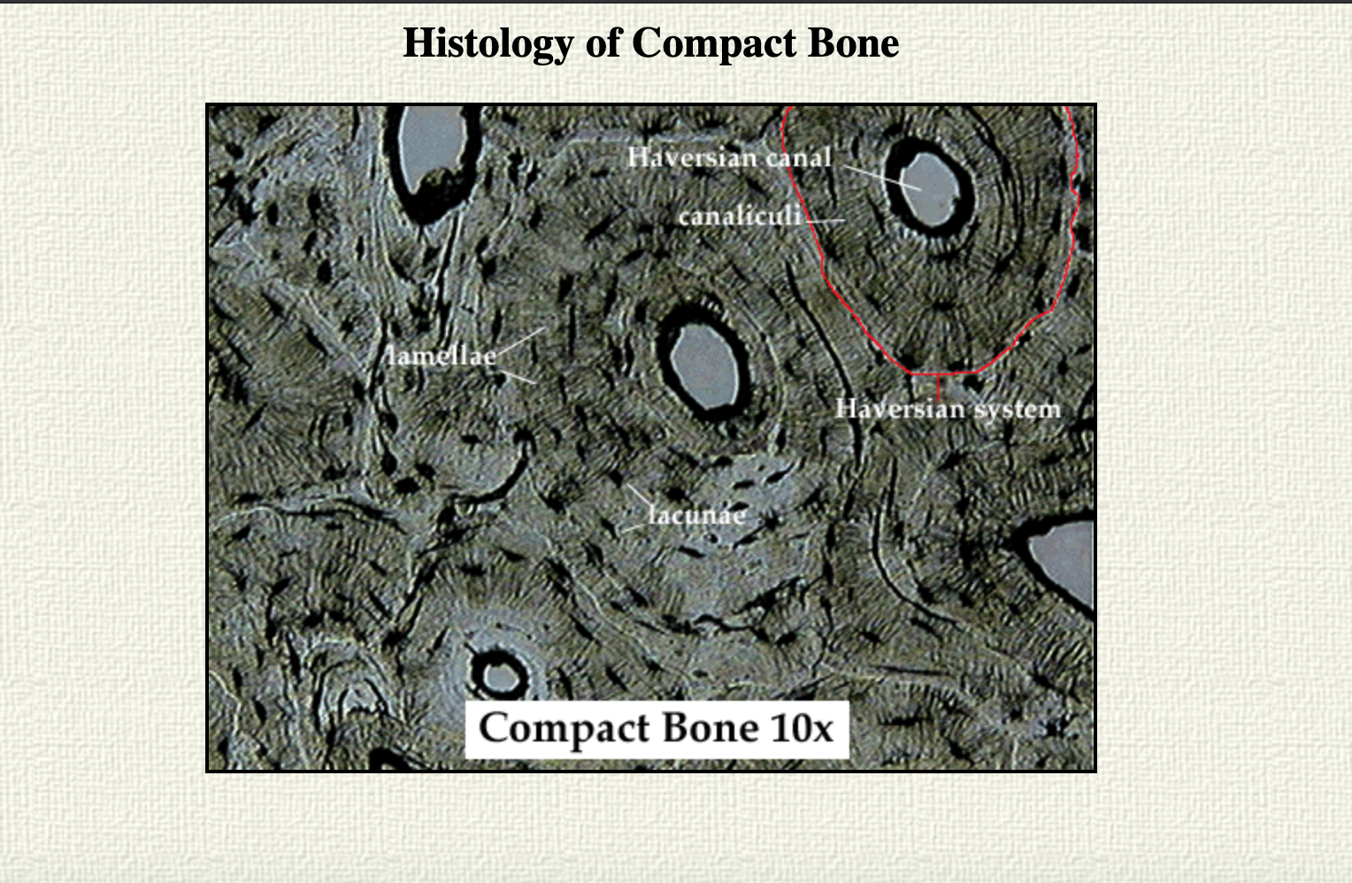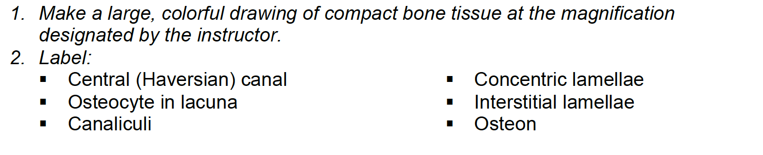
Interstitial Lamellae
Concentric Lamellae
OSTEOCYTE
IN A LACUNA
Osteon
Skeletal Muscle Tissue
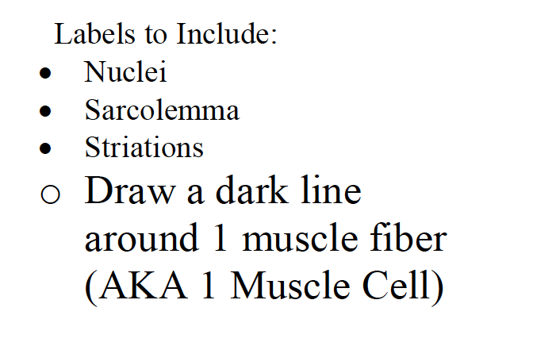 | 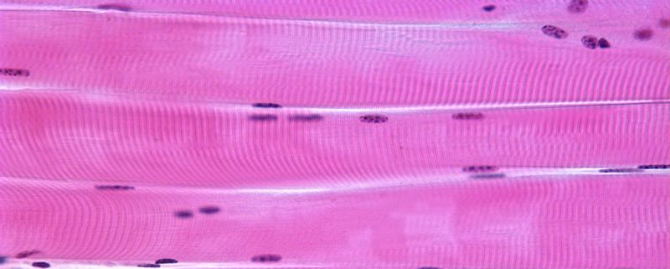Zoom in Even More:  Sarcolemma  Light DarkLight  Striations  (Stripes)

