Name ______________________
Gibbon Conservation Center
19100 Esguerra Road
Santa Clarita, CA 91390
www.gibboncenter.org
Phone: 661-296-2737

Tours
The Gibbon Conservation Center is open to the public every Saturday and Sunday morning from 9:30 a.m. to noon (except for rainy days and holidays). A tour is given at 10:00 in the morning. Admission: $15 (adults); $12 (Teens and Students); $10 (seniors); $5 (children 6-12); $0 (Children under 5). Checks, cash, and credit cards are accepted. Reservations are not required for the Saturday/Sunday public tours.

Facility
The Gibbon Conservation Center (GCC) was established in 1976 to promote the conservation, study and care of gibbons through public education and habitat preservation. There are currently 4 genera and 19 (possibly 20) species of gibbons in the world. The facility houses the rarest group of apes in the Western Hemisphere and is the only institution in the world to house and breed all four genera of gibbon. GCC has successfully reproduced 7 gibbon species.

Basic Gibbon Facts
Gibbons are small, endangered, arboreal apes that are native to the rain forests of Southeast, South and East Asia. They are also considered to be among the world’s greatest acrobats. They can leap distances of 40 feet at speeds of up to 35 mph while 200 feet above the ground. This swinging from branch to branch is called brachiating. Gibbons are also one of the few serial monogamous primates, and whether on the ground or in the trees, they are known for their dexterity and ability to walk upright.
Gibbons are often referred to as the “songbirds” of the primate family and the most musical land mammals. Gibbons can project their voices up to 2 miles through the dense rain forest canopy. As the gibbons wake at dawn, you will see an arm poke out of a sleeping box and then perhaps a leg, a head... and finally each gibbon is awake. There'll be some grooming, some yawning and a little chatter. They'll stretch a little and swing down to make sure no trespassers have come in during the night to claim their territory. Just then, one gibbon family will start their morning song and the rest of the gibbon families will join in with their unique territorial calls.

Volunteer/Internships/Research Opportunities
Do you have a few hours? A few days? The GCC is always looking for students that would be interested in volunteering, research and internships. Contact the GCC through their website for more information.

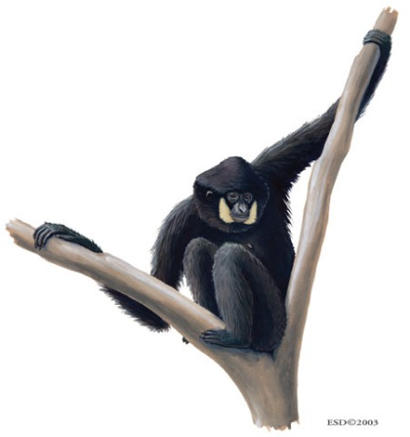
Questions (Common characteristics of gibbons)
- Why are gibbons considered apes and not monkeys?

- Gibbons primarily move through the trees by brachiating. What is brachiating?

- What do gibbons and humans have in common with regards to movement on the ground?

- Gibbons are one of the few mammals that display the behavior of serial monogamy. What is serial monogamy?

- What is the purpose of gibbon vocalization (singing)?

- Why are some gibbons at the facility on given birth control?

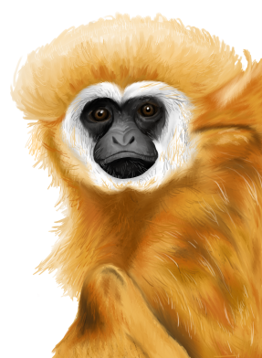
Questions Regarding Different Gibbon Species)
Pileated Gibbon
- Pileated means “capped”. What is the advantage of having this coloration?

- How do adult male and female Pileated Gibbons differ in coloration?

- What is the coloration of an infant Pileated Gibbon and why is it beneficial to the infant gibbon?

- What are the main reasons Pileated Gibbons are endangered?

Eastern Hoolock Gibbon
- Describe the change in coloration of the Eastern Hoolock Gibbon from infant, to adulthood.

- What is the primary diet of the Eastern Hoolock Gibbon?

- The status of these gibbons is ‘venerable’. Why are these gibbons hunted?

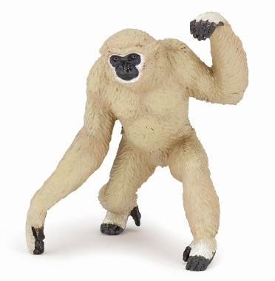
Northern White Cheeked Gibbon
- These gibbons are dichromatic. What does this mean?

- Describe the change in coloration of the Northern White Cheeked Gibbon from infant to adulthood.

- What is the reason that these gibbons are considered “critically endangered”?

Javan Gibbon
- What area of the forest do Javan Gibbons live?

- When are they active?

- What strategy can be used by humans to help Javan Gibbons survive?

- Javan Gibbons are in the genus Hylobate. What is the definition of Hylobate?

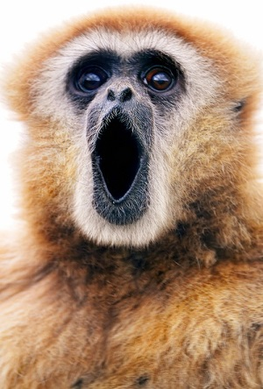
Siamang Gibbon
- How do Siamangs compare with other gibbons with regards to their size?

- What is the purpose of the throat sac?

- What is unique about the second and third toes of the Siamang?

Lastly…
How would you describe the sounds of the gibbons singing all at once?

