Contributed by: Ann Reisenauer, San Jose State University
Scientist Spotlight:
Shinya Yamanaka
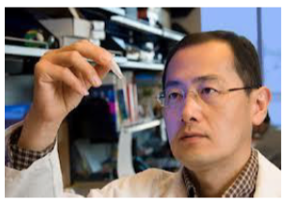
Dr. Shinya Yamanaka is a Japanese physician and researcher who studies stem cells at Kyoto University and the Gladstone Institutes in San Francisco. His discovery of iPS cells brought medical science a step closer to using stem cells to treat a wide range of diseases. He won the Nobel Prize in Medicine in 2012 for this work. Major hurdles remain, but the discovery of iPS cells is a key breakthrough in stem cell research.
Please view the NOVA special called Stem Cells Breakthrough at
http://www.pbs.org/wgbh/nova/body/stem-cells-breakthrough.html

After viewing the video, write a 250 word or more reflection with your responses to what you heard. You might wish to discuss:
- What are the characteristics of stem cells? Why are iPS cells also called reprogrammed cells?
- What are some advantages of iPS cells as compared to embryonic stem cells?
- Explain how stem cells can be used in medicine.
- What was most interesting or most confusing about the video?
- What did you learn about the types of people who do science?

