Contributed by: Allyson Spence, Sonoma State University
Scientist Spotlight:
Nick Hud
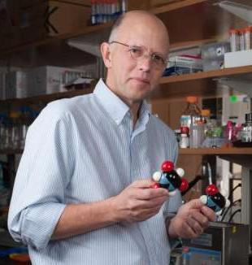
Nick Hud is a Georgia Tech professor of chemistry and biochemistry. He studies the structure and function of DNA in viruses as well as the origin of life, with a particular focus on RNA. He discusses some of the difficulties he experienced when sharing his research with non-scientists such as his mother as well as with the Catholic Church. How he finally is able to communicate the beauty of scientific research is definitely unconventional.

1. Listen to the Story Collider podcast by Nick Hud by clicking the red play button here.
2. Then, review this article about Dr. Hud’s research into the RNA origin of life.

After listening to the story and reading the article, write a 250 word or more reflection with your responses to what you heard. You might wish to discuss:
1) What was most interesting or most confusing about the articles you read/listened to about Dr. Hud?
2) What can you learn from these articles about Dr. Hud’s research into the early chemical reactions that may have taken place to form the early building blocks of life?
3) What do these articles tell you about the types of people that do science?
4) What new questions do you have after reviewing these articles?

