Contributed by: Jeff Schinske, DeAnza College
Scientist Spotlight:
Lawrence David
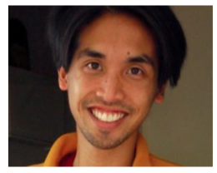
We will soon be looking into the body's defenses and the microbes with which our bodies interact. This leads us to our next scientist. Lawrence David is a Filipino-American biologist currently working as a professor at Duke University and Harvard. His work focuses on the trillions of bacteria that live on and in the human body, and he is particularly interested in how bacteria contribute to health and disease in the developing world, including in Bangladesh and other non- western areas. He also helped start a website to showcase illustrated, science-related poetry (http://www.sciku.org/)

- Please click here (http://www.storycollider.org/stories/2016/1/6/lawrence-david-an-extreme-self-study) and listen to the story told by Lawrence David. This is from a podcast called Story Collider, which includes a wealth of stories about how science has impacted people􏰀s lives in interesting or amusing ways.
- Next, click here (http://www.npr.org/sections/thesalt/2013/12/10/250007042/chowing-down- on-meat-and-dairy-alters-gut-bacteria-a-lot-and-quickly) to read an article reporting on some of the striking results of Lawrence David's work. (or for a more advanced class I would use a brief Nature article on his work http://www.nature.com/nature/journal/vaop/ncurrent/abs/nature12820.html)

After listening to the story and reading the article, write a 250 word or more reflection with your responses to what you heard. You might wish to discuss:
1) What was most interesting or most confusing about the podcast and article?
2) What can you learn from the podcast/article about the relationships between our body and bacteria?
3) What does this podcast/article tell you about the types of people that do science?
4) What new questions do you have after hearing the story?

