Contributed by: Katherine Farrar, UCSF
Scientist Spotlight:
Clare Fieseler
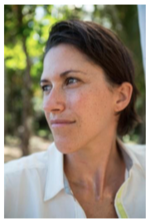
How Clare Fieseler describes herself: Ecologist specialized in climate change resilience, coral reefs, and resource management. Multimedia journalist and science writer. Producer of digital science outreach. National Geographic Explorer. (http://www.cfieseler.com/about/)
Watch this brief National Geographic documentary about Clare Fieseler’s portrait project about women scientists, titled “Outnumbered”, by clicking here. (You can view the portraits by clicking here.) Then listen to this Nerdette Podcast interview with Clare Fieseler (minute 1:20 to 18:45) by clicking here.
You may wish to explore Claire Fieseler’s Twitter feed and the projects section on her website, as well as other productions she has been involved with, such as this multimedia documentary about conservation of the Boca del Toro region of Panama.

After listening to the story and reading the article, write a 250 word or more reflection with your responses to what you heard. You might wish to discuss:
1) What was most interesting, surprising, or unusual about the portrait project or interview with Clare Fieseler?
2) What is your personal experience with science in the media? What types of science multimedia for the public would you like to see more of in the future?
3) What do the documentary, interview, and other media sources tell you about the types of people who do science?
4) What new questions do you have after doing this scientist spotlight?

