Cellular Respiration:
3 Parts: | ________________________________ | ________________________________ | ______________________________
What’s happening to carbon?

Main Function
Visual

In Out | 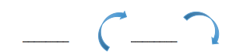

Photosynthesis
2 Parts: | ________________________________ |  |  | ________________________________
Sub Parts:

Main function
Visual

