BBQ#12: Why do we breathe?¹

I. Cellular Respiration
The chemical equations shown below summarize the cellular respiration of glucose (a simple sugar). Glucose and oxygen are the inputs for a series of chemical reactions which produce carbon dioxide and water, and provide the energy to make ATP molecules. The actual process of cellular respiration in cells requires many steps which are not shown here.

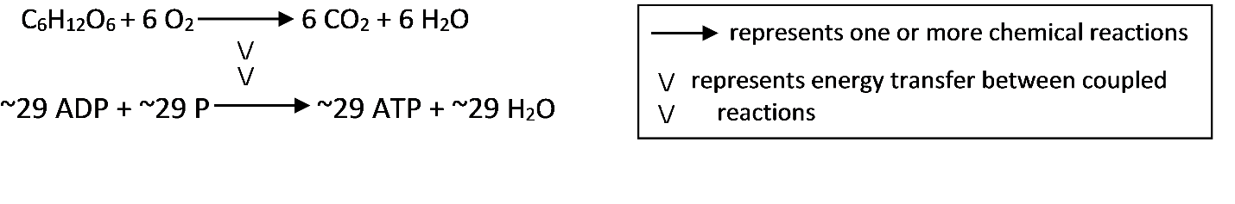
1. Write the names of each of the molecules in these chemical equations.

2. How do our bodies get glucose and other organic molecules for cellular respiration?

If you search for "cellular respiration equation" on the web, some of the most popular sites give the following chemical equation for cellular respiration of glucose.
C₆H₁₂O₆ + 6 O₂ 6 CO₂ + 6 H₂O + ATP

3a. What is wrong with this chemical equation? (Hint: Think about where the atoms in an ATP molecule come from.)

3b. Write a corrected version of this chemical equation that gives a more accurate summary of cellular respiration. (Hint: This corrected chemical equation should combine the two coupled reactions shown in the middle of this page.)

