Lab Report Format:
All content is from the Bio11 lab manual, page 125-127
Format:
- Double Spaced
- Stapled (Upper Left)
- Follows the following format
- Paragraph form
Sections:
- Cover Sheet
Cover Sheet:
Name(s): _________________________
LAB Section: __________________
Date: __________________________
Skip 10 lines
Title (should be descriptive)

Body of the Report:
Title of Section (centered or left at the top of each page)

2. Results: (Show your Data)
- In a paragraph, Describe/discuss your results.
  - How does your data compare to class ave.
  - What trends did you see
  - What did the data show?
- Graph the data to visualize it
  - Title
  - X Axis – Independent Variable (label, units, even increments)
  - Y Axis - Dependent Variable (label, units, even increments)
  - Include a sentence that describes the TRENDS you see in each graph
Example:
The Effect of Egg Weight on Hatchling Weight
- 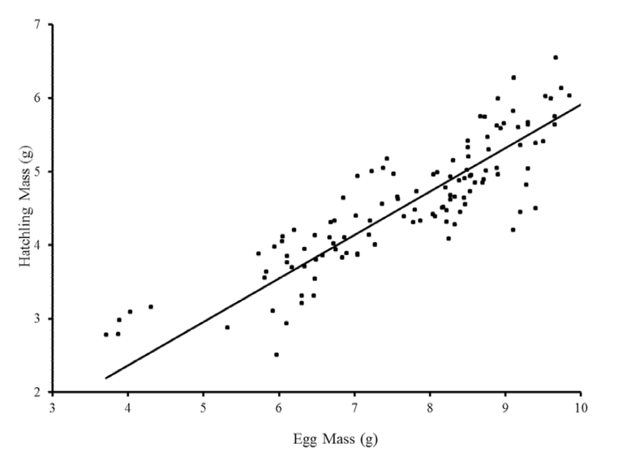
- Graph 1. —The relationship of initial egg mass to wet hatchling mass in Emys marmorata. A line graph showing that larger eggs produced larger hatchlings.
- Diagram (not mandatory)
  - Include a sentence that describes each graph

3. Discussion: (Discuss your data and the experiment)
- Why did we measure respiration rate, when we really wanted to calculate cell respiration?
- Discuss trends seen in data.
  - Connect the trends to the effect of water temperature on cellular respiration.
- How does your data compare to the class averages?
- What did you think of your results?
  - Are they what you anticipated in the beginning when you made your hypothesis?
- Any problems with the experiment? (Human error, miscalculations etc.)
  - Was some of the data bad? Explain why? Did you keep it or throw it out (calculate the averages without it?)
4. Thought Questions from Lab:
- ANSWER QUESITONS FROM LAB

Attach rubric to front: Rubric
Lab Report Rubric:
Pts | Points Possible | Section
 | /2 | 0. Format:  - Double Spaced  - Stapled (Upper Left) | - Headers for each section  - Follows the following format  - Paragraph form
 | /1 | 1. Cover Page  Name: _________________________  LAB Section: __________________  Date: __________________________  Skip 10 lines  Title (should be descriptive)
 | /7 | 2. Results: (Show your Data)  - In a paragraph, Describe/discuss your results.  - How does your data compare to class ave.  - What trends did you see  - What did the data show? | - Graph the data to visualize it  - Title, X Axis, Y Axis, units  - Include a sentence that describes the trend you see each graph and data table
 | /7 | 3. Discussion: (Discuss your data and the experiment)  - How were we using breaths to actually measure cell respiration?  - Discuss trends seen in data. (Connect the trends to the effect of water temperature on cellular respiration)  - How does your data compare to the class averages?  - What did you think of your results?  - Are they what you anticipated in the beginning when you made your hypothesis?  - Any problems with the experiment? (Human error, miscalculations etc.)  - Was some of the data bad? Explain why? Did you keep it or throw it out (calculate the averages without it?)
 | /3 | 4. Discussion Questions:  - ANSWER QUESITONS FROM LAB  Why take three rates Why take data from class Correlation between Water temp & Resp. Rate - Explain trend  What other factors affect resp rate? - How is that advantageous? Control? Sources of error
Total Points:
/20
A=20-18 B= 17-16 C= 15-14 D= 13-12 F=11 & below

