Practice Exam #3:

Genetics: Please refer to you genetics HW to practice monohybrid crosses, standard dominance, co dominance, incomplete dominance and sex linked crosses.
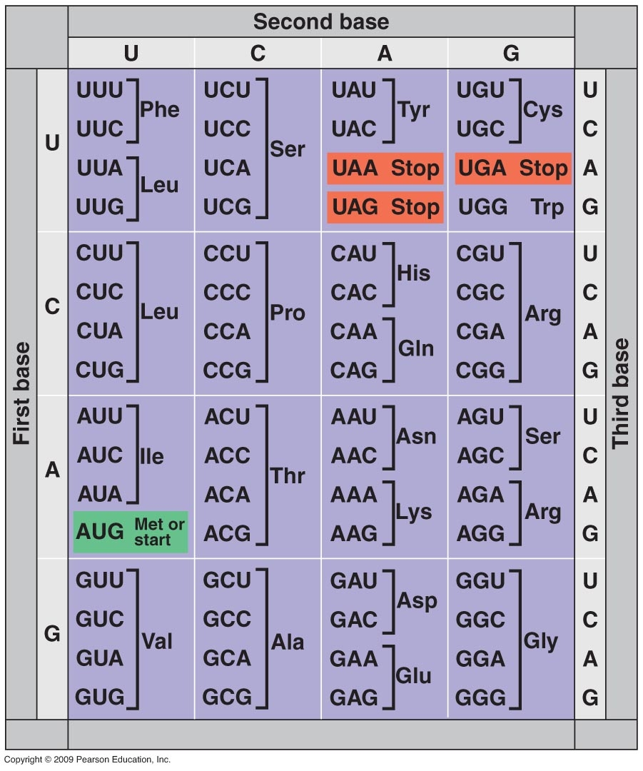

DNA and RNA Structure:
- What are the three components of a nucleotide?
- Role of the enzyme following enzymes:
polymerase 3 | polymerase 1 | Helicase | Ligase
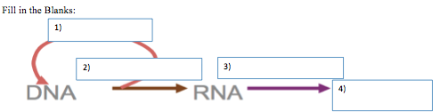
- Fill in the blanks

DNAProtein
- Gene sequence:
T T A C T T C C A G A C C A C T A
Replication: _______________________________________________________

Transcription: _______________________________________________________

Translation: ___________________________________________________________

Evolution & Speciation:
- What is a homology?

- What were the two key observations Darwin made about natural selection?

Ecology - Population:
- What 2 factors contribute to making a population larger ?
- Disease is a density dependent or density independent factors?

- What is an invasive species? Why are they detrimental to the environment?

- Same the three survivorship curves, and which is a R strategist and which is a K strategist?
Curve | Name: | Circle one
A |  | R, K, or Neither
B |  | R, K, or Neither
C |  | R, K, or Neither
- Draw: Logistic growth and label carrying capacity:

- What is a limiting factor and how is it tied to carrying capacity?

- How are Boom – Bust population dynamics shown throughout evolution? Think mass extinction.

Ecology - Community:
- Biodiversity
  - Why is it important?

  - What three factors are involved?
- There are three types of interspecific interactions, what are they and identify which is +/+, +/-, -/-
Circle one: +/+ +/- -/- | Circle one: +/+ +/- -/- | Circle one: +/+ +/- -/-
- Which of the above results in the competitive exclusion principle?

Ecology - Ecosystems:
- Why are roots so important to primary succession?

- What is a specie’s niche?

- Why cant their be more than 6 levels in a food web? (Think of the 10% rule.)

- Why is light so important in a marine Biome?

- Explain the phosphorus cycle?

