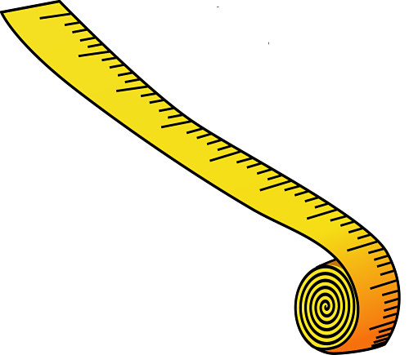
Size and Scale
- I will Check next week in lab
Thinking Like a Biologist in Size and Scale
Due at start of Lab#3, Staple into Blue Book

Part I:
- Revisit your Biology Size and Scale Strip Set that you worked in class on with a partner. Do the exercise again by yourself, putting the strips in order from the LARGEST to the SMALLEST.
- Write out a list of YOUR predicted order of the strips from LARGEST to SMALLEST here:

- Write a paragraph (≥200 words) about: (attach it to this paper)
1) what strategies you used to arrive at this prediction,
2) which items you are most sure about their relative size, and
3) which items you are least sure about their relative size.
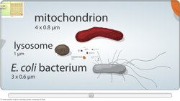
Part II:
ONLY AFTER COMPLETING PART I (on your honor!), explore this website: http://learn.genetics.utah.edu/content/cells/scale/

1. As you move the scale bar and zoom in, think about how you would need to REVISE YOUR PREDICTED LIST of items from LARGEST to SMALLEST!

2. Also, think about WHAT EACH OF THESE BIOLOGICAL ITEMS ARE MADE UP OF…Think about which of the items are: …collections of cells?
…single cells?
…only collections of molecules?
…only single molecules?

Part III:
Write another paragraph (≥200 words) about:
1) What did you learn from the website that SURPRISED you the most.
2) What did you learn that CONFUSED you the most.
3) What new strategies might you use if you were asked to predict the relative size of a new set of biological items.
Red Blood cell | Grain of Rice
Mitochondrion (organelle) | Ribosome (collection of molecules)
Amoeba cell | Human Egg cell
Yeast cell | Grain of Salt
E. Coli Bacterial cell | Skin cell Sperm cell
X Chromosome (collection of molecules) | Adenine molecule (nucleotide)
Phospholipid molecule | Hemoglobin molecule (protein)
Methionine molecule (amino acid) | Glucose molecule (sugar)
Water molecule | Carbon atom

