Practice Exam #3:

Cell Division:
- Draw the cell cycle and identify the section that is affected by cancer?

- How does a mutation cause cancer?

- What is a mutation? How do mutations affect protein?

- There are 2 categories of mutations that cause cancer (think of the pedals in a car). How does each affect a cell?

Genetics: Please refer to your genetics HW (BBQ) to practice monohybrid crosses, standard dominance, co dominance, incomplete dominance and sex linked crosses.

DNA and RNA Structure:
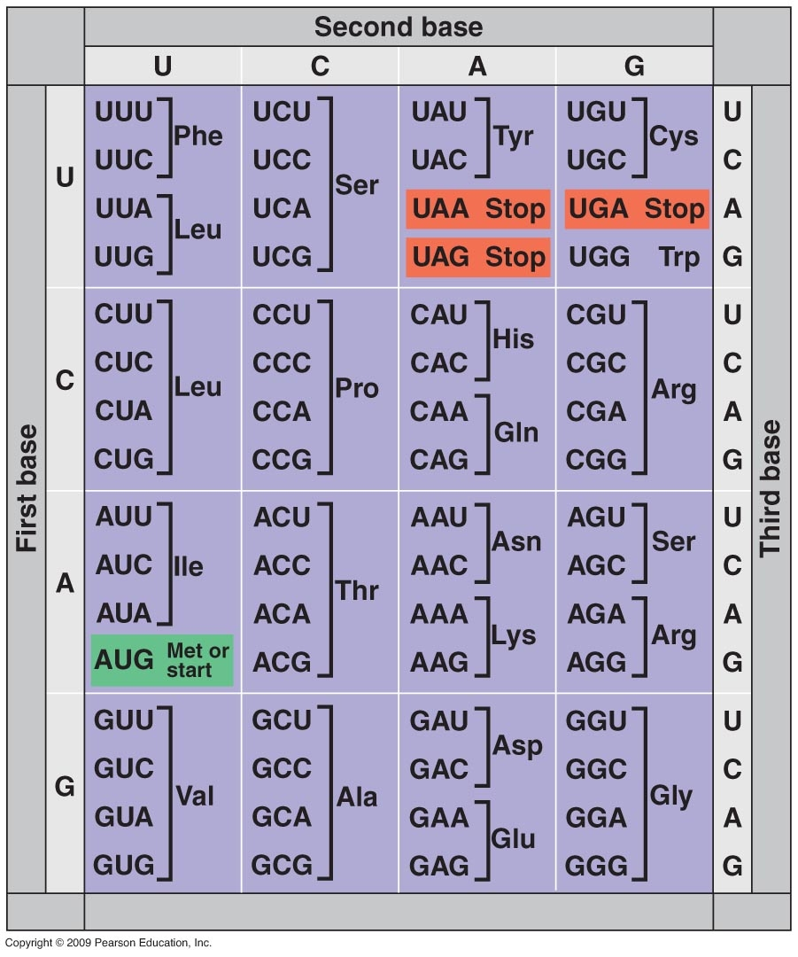

- What are the three components of a nucleotide?

- Role of the enzyme following enzymes:
polymerase 3 | polymerase 1 | Helicase | Ligase

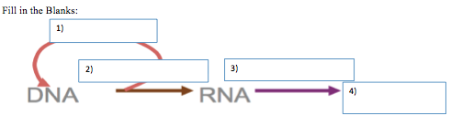
- Fill in the blanks

DNAProtein
- Gene sequence:
T T A C T T C C A G A C C A C T A
Replication: ___________________________________________________________

Transcription: _________________________________________________________

Translation: ___________________________________________________________

