1. Classification: Domain ___________________, Kingdom: _______________

2. Cells: Prokaryotic or Eukaryotic?

Meaning?____________________________________________________________________
What unique structures do plant cells have compared to animal cells?

A.________________________B._______________________C._______________________

Does a plant cell have a plasma membrane?___________

3. Obtaining Energy: Autotroph or Heterotroph?

Meaning?____________________________________________________________________

4. What is the overall Photosynthesis equation?

Can you balance this equation? (How many of each molecules are used/made?)

5. Where do plants get: CO₂? __________________________

How does it get into the plant?_____________________________________________________
What is the role of the guard cell? __________________________________________________
Into the cells?__________________________________________________________________

How does O₂ leave the plant?____________________________________________________

6. Where in the plant does most of the P.S. take place? _________________________________

What structure moves C₆H₁₂O₆ to the rest of the plant?_________________________________

7. How do plants get: H₂O? _______________________________________

What structure moves H₂O up to the leaves?_____________________________________

8. P.S. has two parts.
I. Light Dependent Reaction: | II. Light Independent Reaction
Energy from the sun splits ___________ to form ___________ + ATP + NADPH | is also called: __________________________  Uses ATP + NADPH and fixes _______________ ____________________ (end product)
9. All of the biomass in a 100 foot tree (the roots, stems, leaves, bark) came from where? (What is the carbon source??)
___________________________________________________________________

10. Do plant cells use Cellular Respiration? _____________________________
Do they have an organelle that specializes in respiration?_________________________

11. Evolution in Plants- fill in the key features of these groups:

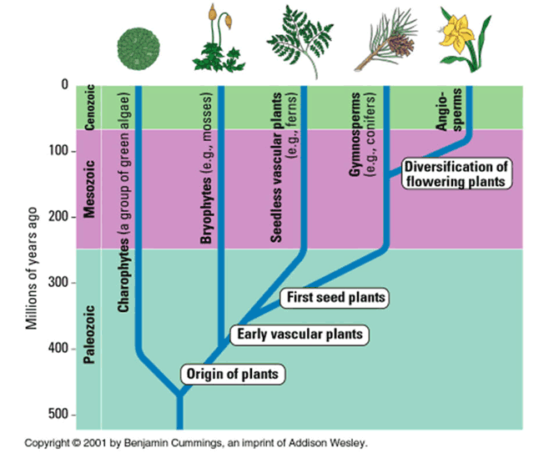

12. The life history of all land plants includes ________________________________________
which means that two forms of the same plant exist.

Gametophyte: a (haploid or diploid?) plant which produces male & female ______________
(= haploid sex cells) through the process of (mitosis or meiosis?).
Gametes fuse at fertilization, and grow into a sporophyte.
Sporophyte: a (haploid or diploid?) plant which produces spores (haploid cells) through the
process of (mitosis or meiosis?). Spores grow and develop into the gametophyte.



