Contributed by: Susan White, Cañada College and Mission College
Scientist Spotlight:
Pardis Sabeti
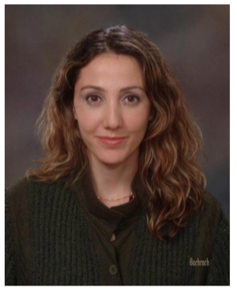
Pardis Sabeti is a geneticist at Harvard University. She studies infectious diseases, such as malaria and Ebola, in particular looking at their DNA for mutations. When she’s not in the lab or traveling to Africa for her research, she performs with her alternative rock band, Thousand Days. Dr. Sabeti was born in Iran and came to the U.S. with her family as a young child.

- Watch this video about Dr. Sabeti’s scientific and musical careers by clicking here.
- Now read this article about Dr. Sabeti’s recent work on the Ebola virus by clicking here.
  - Please read at least until the picture of the aid worker, although you may read the whole article if you wish.
- If you’d like to hear Dr. Sabeti􏰀s band play or hear more from her about her research, you can find a number of videos on YouTube.

After watching the video and reading the article, write a 250 word or more reflection with your responses to what you heard. You might wish to discuss:
1) What was most interesting, surprising, or unusual about the video about Pardis Sabeti and her professional interests?
2) What can you learn about Ebola, the virus that causes it, and how it spreads from the article?
3) What do the video and article tell you about the types of people that do science?
4) What new questions do you have after doing this scientist spotlight?
5) What does her research have to do with Ecology and Evolution?

