Contributed by: Zannie Dallara – Bakersfield College
Scientist Spotlight:
Jennifer Doudna
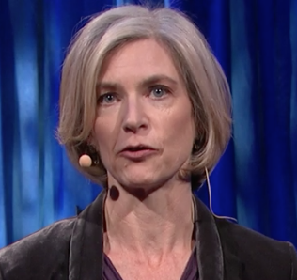
Geneticist Dr. Jennifer Doudna co-invented a groundbreaking new technology for editing genes, called CRISPR-Cas9. The tool allows scientists to make precise edits to DNA strands, which could lead to treatments for genetic diseases ... but could also be used to create so-called "designer babies." Doudna reviews how CRISPR-Cas9 works -- and asks the scientific community to pause and discuss the ethics of this new tool. – Ref: TEDGlobal>London

CRISPR stands for clustered regularly interspaced short palindromic repeats.

Dr. Jennifer Doudna is a member of the departments of Molecular and Cell Biology and Chemistry at UC Berkeley, the Howard Hughes Medical Institute, and Lawrence Berkeley National Lab – She lives and works in California! Here is the link to her lab’s webpage: http://rna.berkeley.edu/

Watch this TED Talk by Dr. Doudna by clicking here.

Read the brief article by Dr. Doudna by clicking here called Mechanisms of RNA-Controlled Gene Expression.

After listening to the story and reading the article, write a 250 word or more reflection with your responses to what you heard. You might wish to discuss:
- What was most interesting or most confusing about Jennifer Doudna and her work?
- Do you have ethical concerns about this research?
- What did you learn from Jennifer Doudna’s research about DNA editing, how it works, and who it impacts?
- What do this video and the background information on Jennifer Doudna tell you about the types of people that do science?
- What new questions do you have after reviewing Jennifer Doudna’s research?

