Contributed by: Steve Waters, Los Medanos College
Scientist Spotlight:
Frances Kelsey
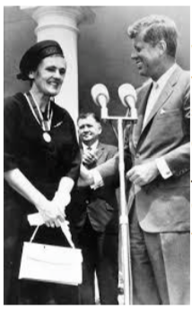
Frances Kathleen Oldham Kelsey (July 24, 1914 – August 7, 2015) was a Canadian pharmacologist and physician. As a reviewer for the U.S. Food and Drug Administration, she refused to approve the sale of thalidomide in the USA because she lacked evidence for the drug's safety during pregnancy. Her concerns proved to be justified when it was shown that thalidomide caused serious birth defects in Europe and Canada. Her refusal to relent to pressure from the drug’s manufacturer prevented many thalidomide- related birth defects in the United States.
- Please view the Globe & Mail video about Frances Kelsey by clicking here.

- Then, read two brief articles.
- The first is about thalidomide and drug safety by clicking here.
- The second is about misconceptions that may arise early while learning about genetics & how they affect interpretation of genetic testing results by clicking here.
- View the Khan Academy video about gene-environment interactions by clicking here.

After listening to the story and reading the articles, write a 250 word or more reflection with your responses to what you heard. You might wish to discuss:
1) What challenges do you think Dr. Kelsey faced in becoming a scientist & working for the U.S. Food and Drug Administration?
2) What can you learn about genetics (genes and traits, environment and phenotypes, disease- associated genes and phenylketonuria) from these articles?
3) What does the thalidomide story have to do with the interaction of genes and environment?
4) What new questions do you have after reviewing this material?
5) What do these articles tell you about the types of people that do science?

