Contributed by: Jill Bouchard, Los Medanos College
Scientist Spotlight:
Agnes Day
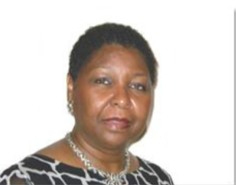
Dr. Agnes Day is a microbiologist and cancer researcher in the college of medicine at Howard University in Washington D.C. Dr. Day grew up the youngest of 13 children in a poor family in Florida. Initially a microbiologist, Dr. Day recalls the strange coincidence that brought her into cancer research, "when [I] got hired at Howard the only lab space available to me at the time was in the cancer center — a beautiful, nice big lab, so I said, 􏰁I’ll take it.' Taking that lab space meant that [I] had to do cancer research. Since I had done research on these connective proteins, [I thought,] 􏰁Hey, I’ll study metastasis. And that’s what I’ve been doing since 1986."
Dr. Day specializes in understanding the genetics of cancer, particularly focusing on the disproportionate impacts of cancer on African American populations.
Read the brief interview with Dr. Day by clicking here
Then review the excerpt from one of Dr. Day's famous journal articles by clicking here (note: don't attempt to understand every biology term, just try to find the main themes of what she did/discovered) – Also, if this link doesn’t work let me know and we can look it up together through the BC library. 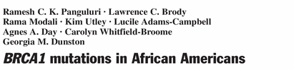

After listening to the story and reading the article, write a 250 word or more reflection with your responses to what you heard. You might wish to discuss:
1) What was most interesting or most confusing about Dr. Day and her work?
2) What did you learn from Dr. Day's research about cancer, what causes it, and who it impacts?
3) What do the article and the background information on Dr. Day tell you about the types of people that do science?
4) What new questions do you have after reviewing Dr. Day's article and background information?

